David Willis

Lingma Acheson

CIT 304

4.13.18

Project 8

Step 1

CREATE TABLE BBT_USERS_TEMP

AS (SELECT * FROM EMPLOYEE_INFO

WHERE employee_id >= 1 AND employee_id <= 10);

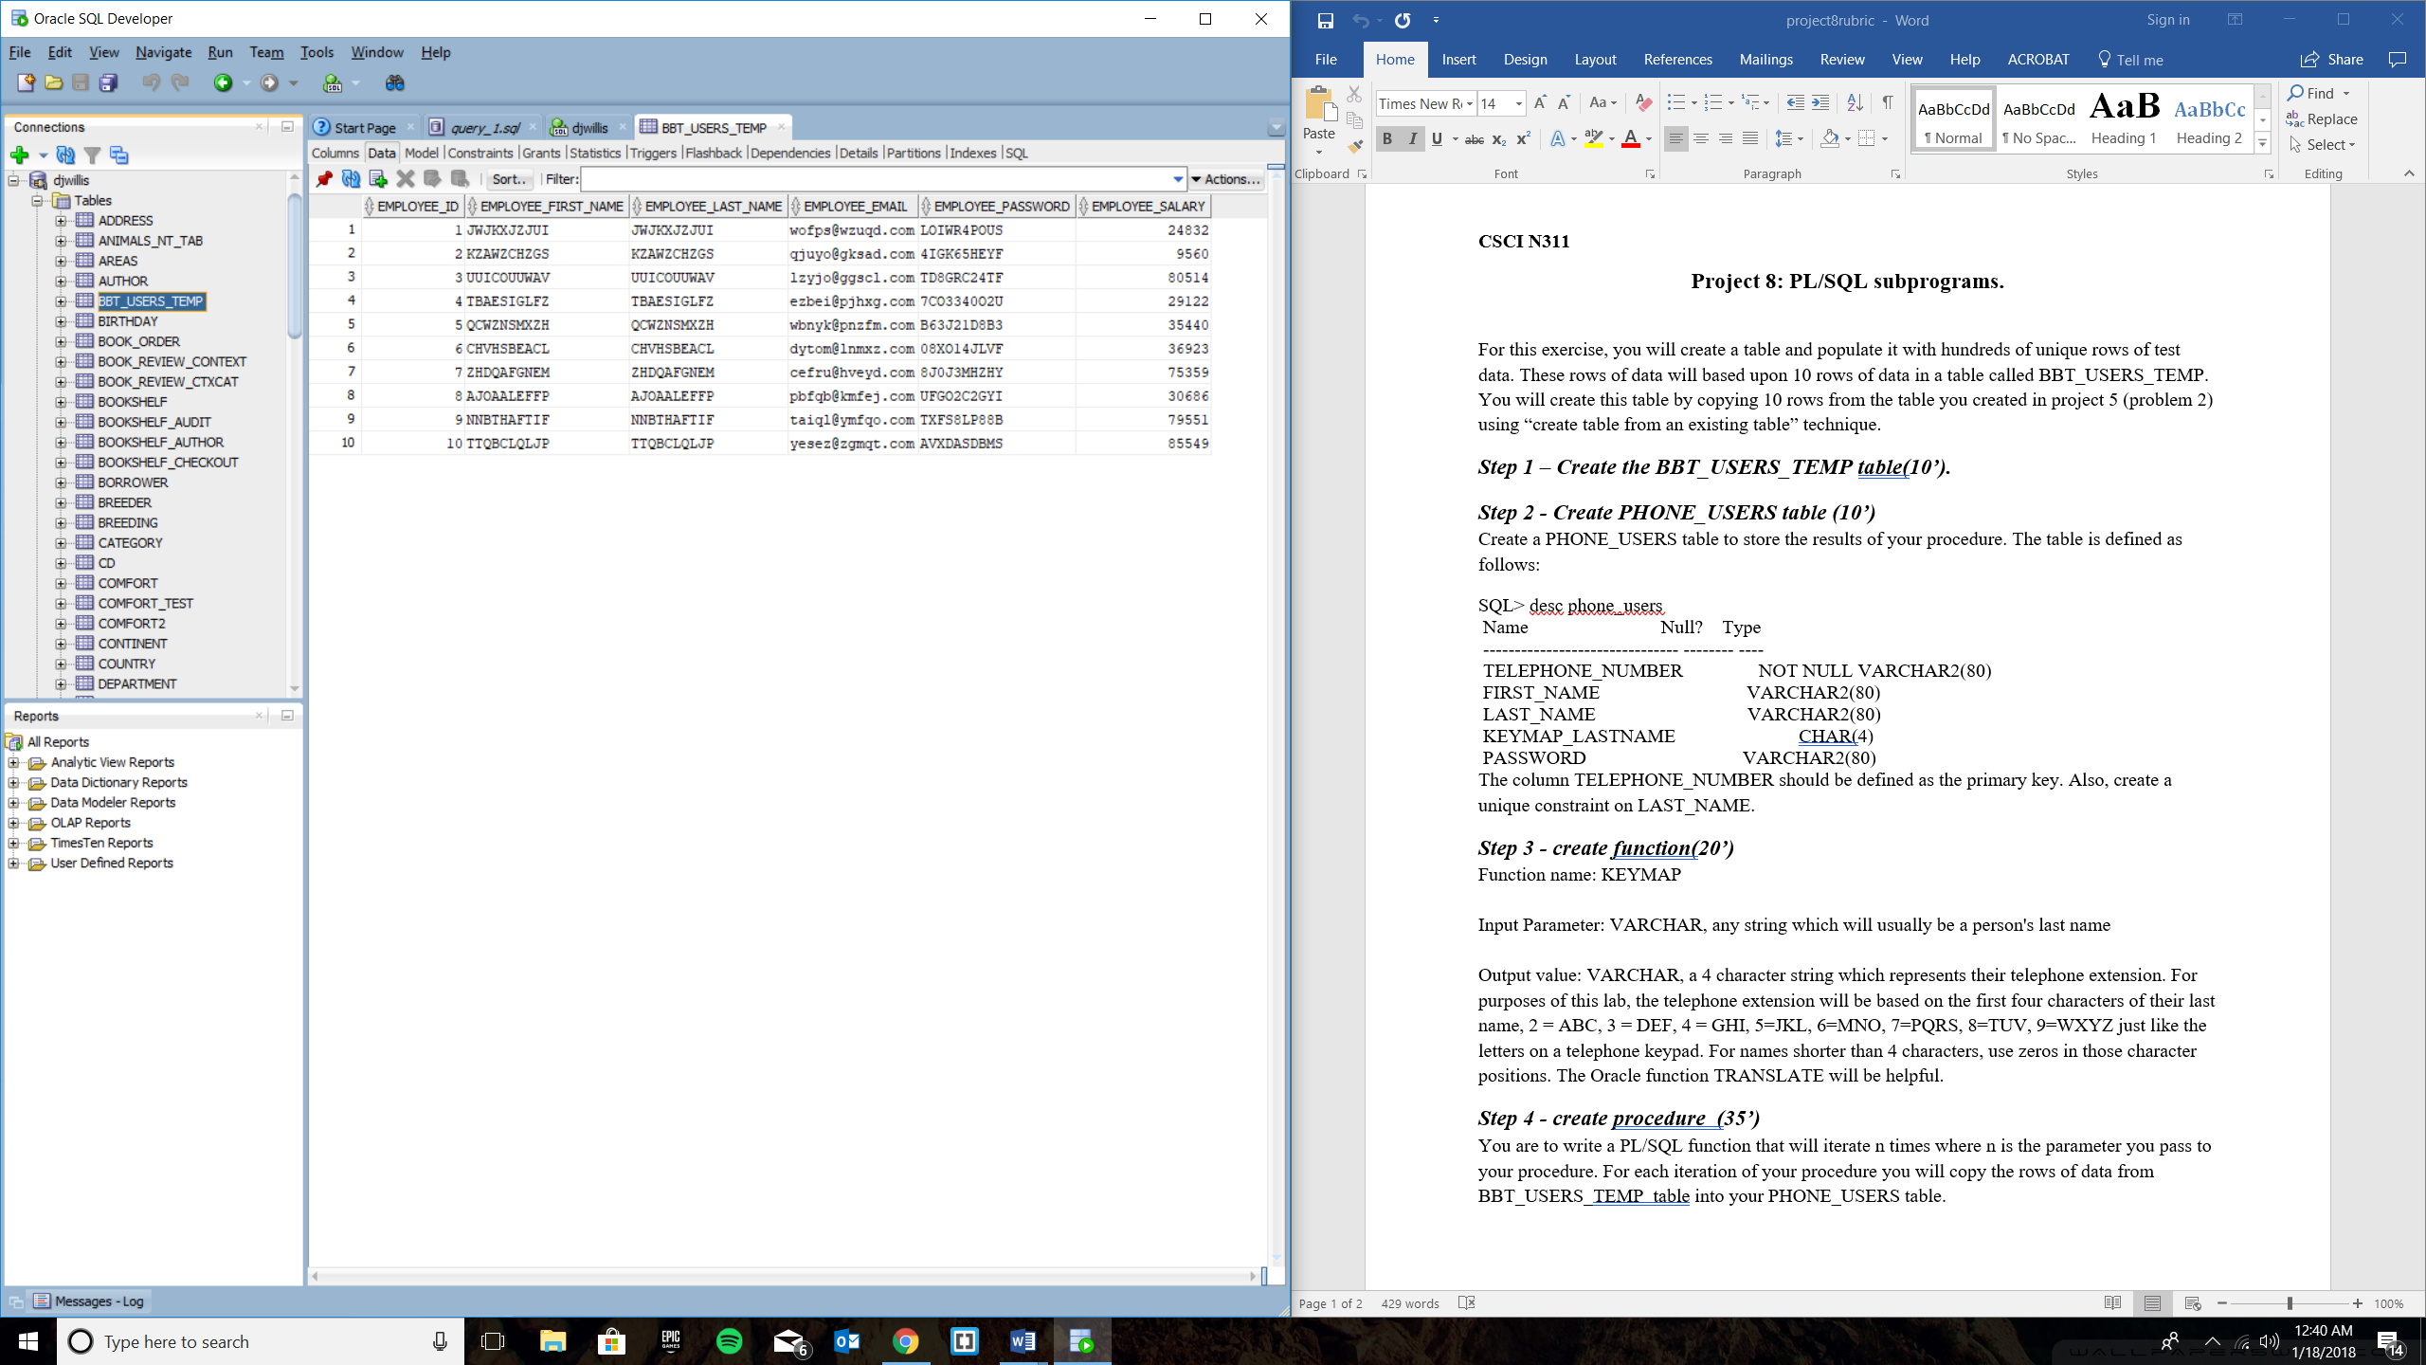

Step 2

CREATE TABLE PHONE_USERS(

telephone_number varchar2(80) not null,

first_name varchar2(80),

last_name varchar2(80),

keymap_lastname char(4),

password varchar2(80),

PRIMARY KEY (telephone_number),

CONSTRAINT constraint_last_name UNIQUE(last_name)

);

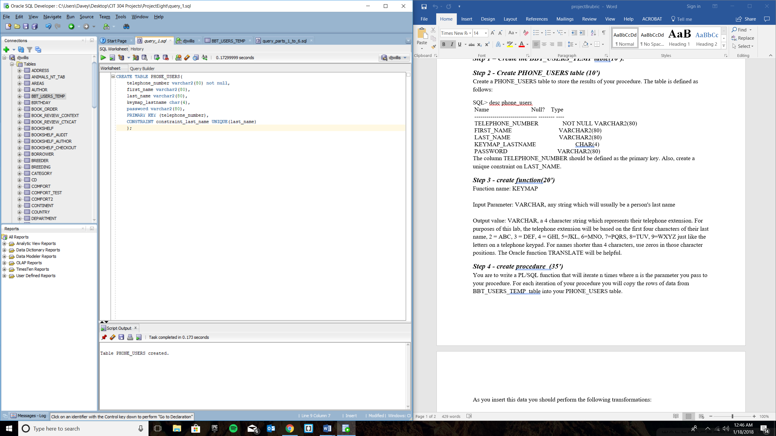

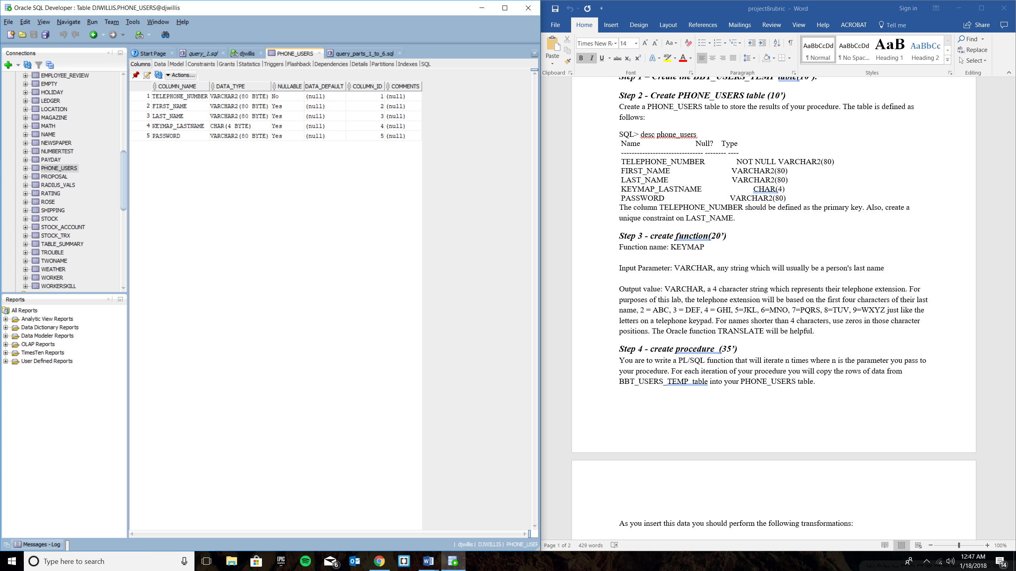

Step 3

create or replace FUNCTION KEYMAP(A_LAST_NAME VARCHAR2)

RETURN VARCHAR2 AS

PHONE_EXT VARCHAR2(40);

BEGIN

SELECT SUBSTR(TRANSLATE(EMPLOYEE_LAST_NAME, 'abcdefghijklmnopqrstuvwxyzABCDEFGHIJKLMNOPQRSTUVWXYZ',

'2223334445556667777888999922233344455566677778889999'), 1, 4)

INTO PHONE_EXT

FROM BBT_USERS_TEMP

WHERE EMPLOYEE_LAST_NAME = A_LAST_NAME;

RETURN (PHONE_EXT);

END;

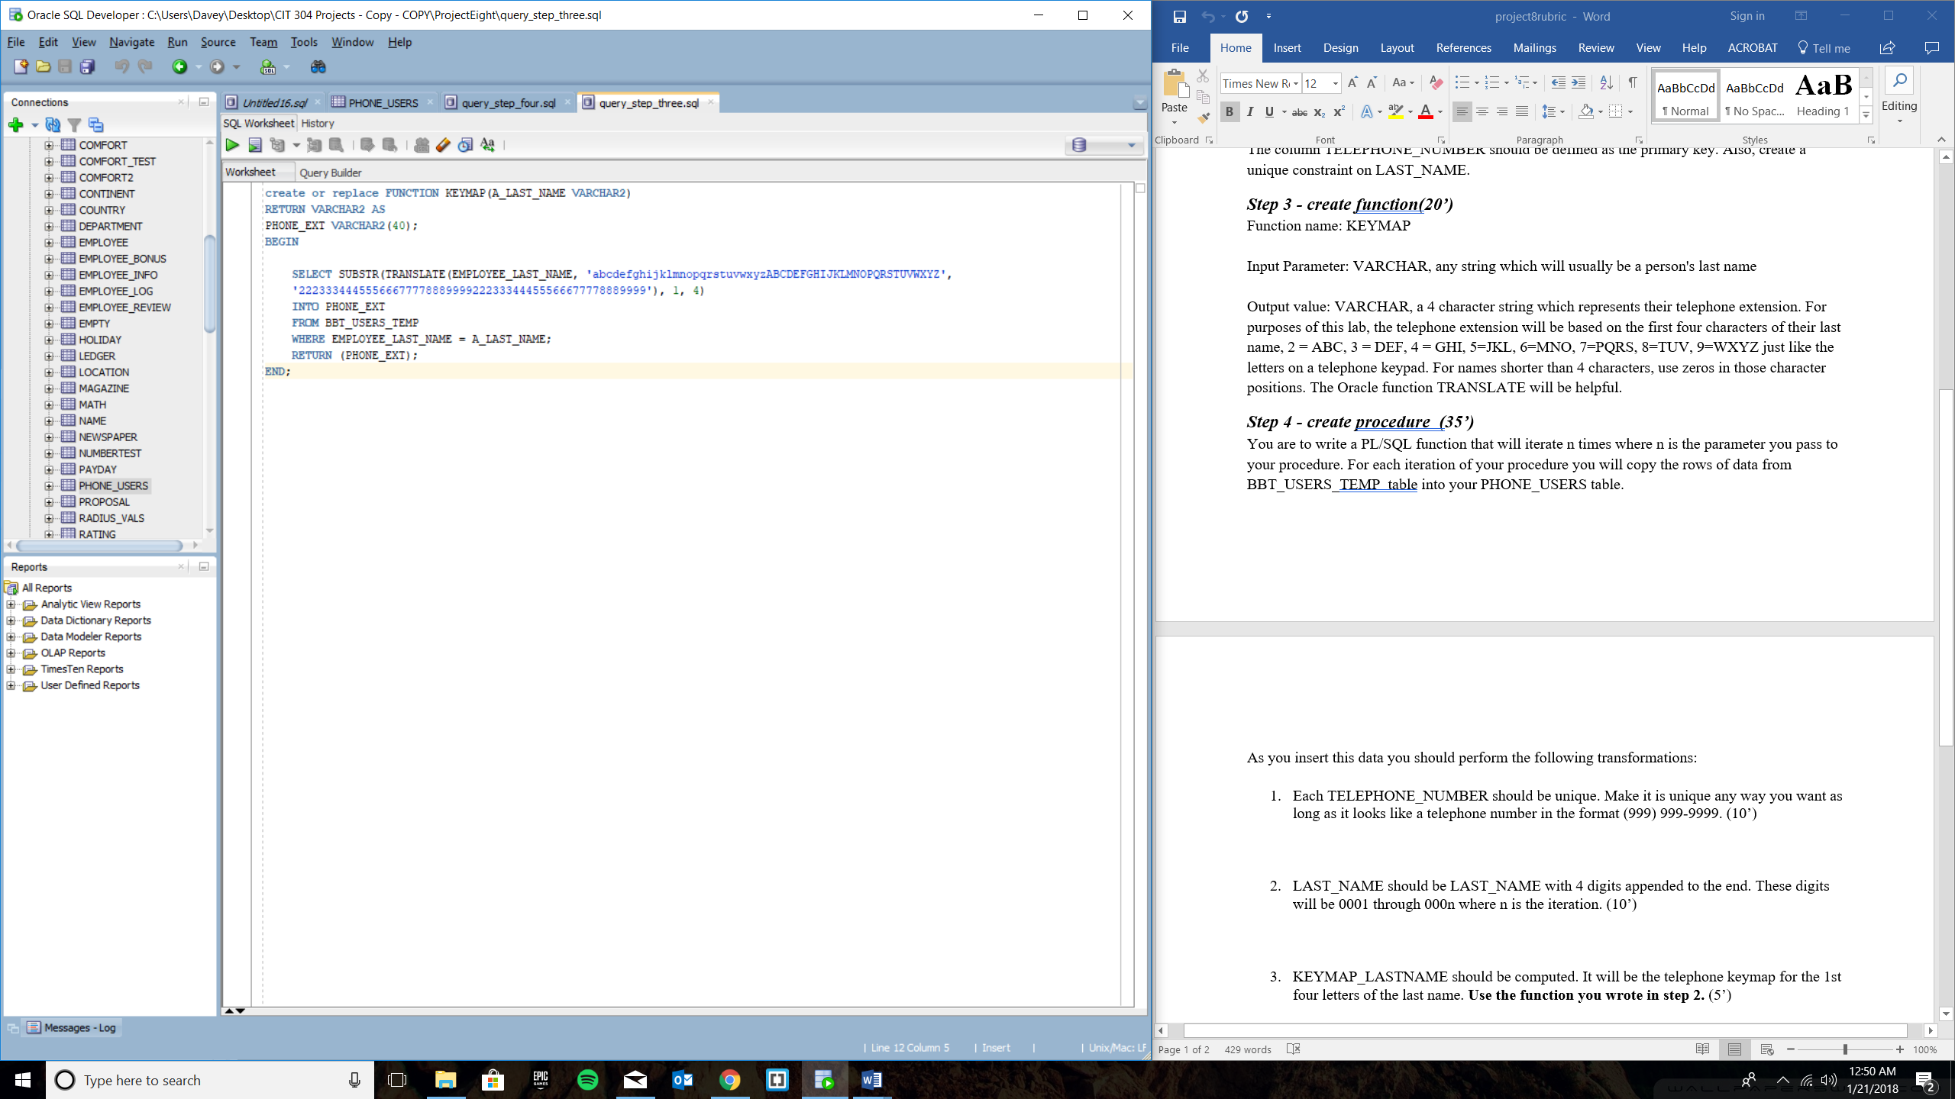

Proof that the function works:

Test Code:

SELECT EMPLOYEE_LAST_NAME, SUBSTR(KEYMAP(EMPLOYEE_LAST_NAME), 1, 4) AS PHONE_EXTENSION

FROM BBT_USERS_TEMP;

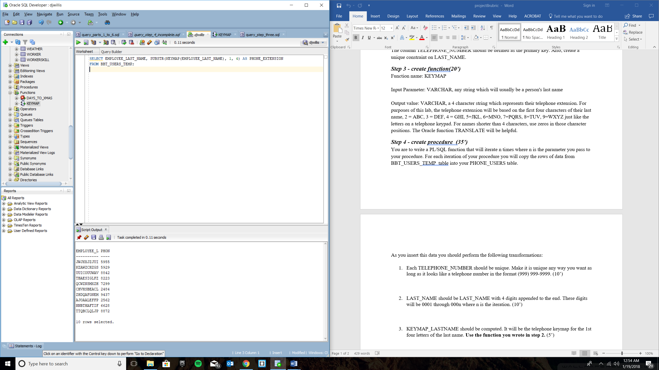

Updated Step 3 to:

create or replace FUNCTION KEYMAP(A_LAST_NAME VARCHAR2)

RETURN VARCHAR2 AS

PHONE_EXT VARCHAR2(40);

BEGIN

SELECT TRANSLATE(EMPLOYEE_LAST_NAME, 'abcdefghijklmnopqrstuvwxyzABCDEFGHIJKLMNOPQRSTUVWXYZ',

'2223334445556667777888999922233344455566677778889999')

INTO PHONE_EXT

FROM BBT_USERS_TEMP

WHERE EMPLOYEE_LAST_NAME = A_LAST_NAME;

RETURN (PHONE_EXT);

END;

Output is:

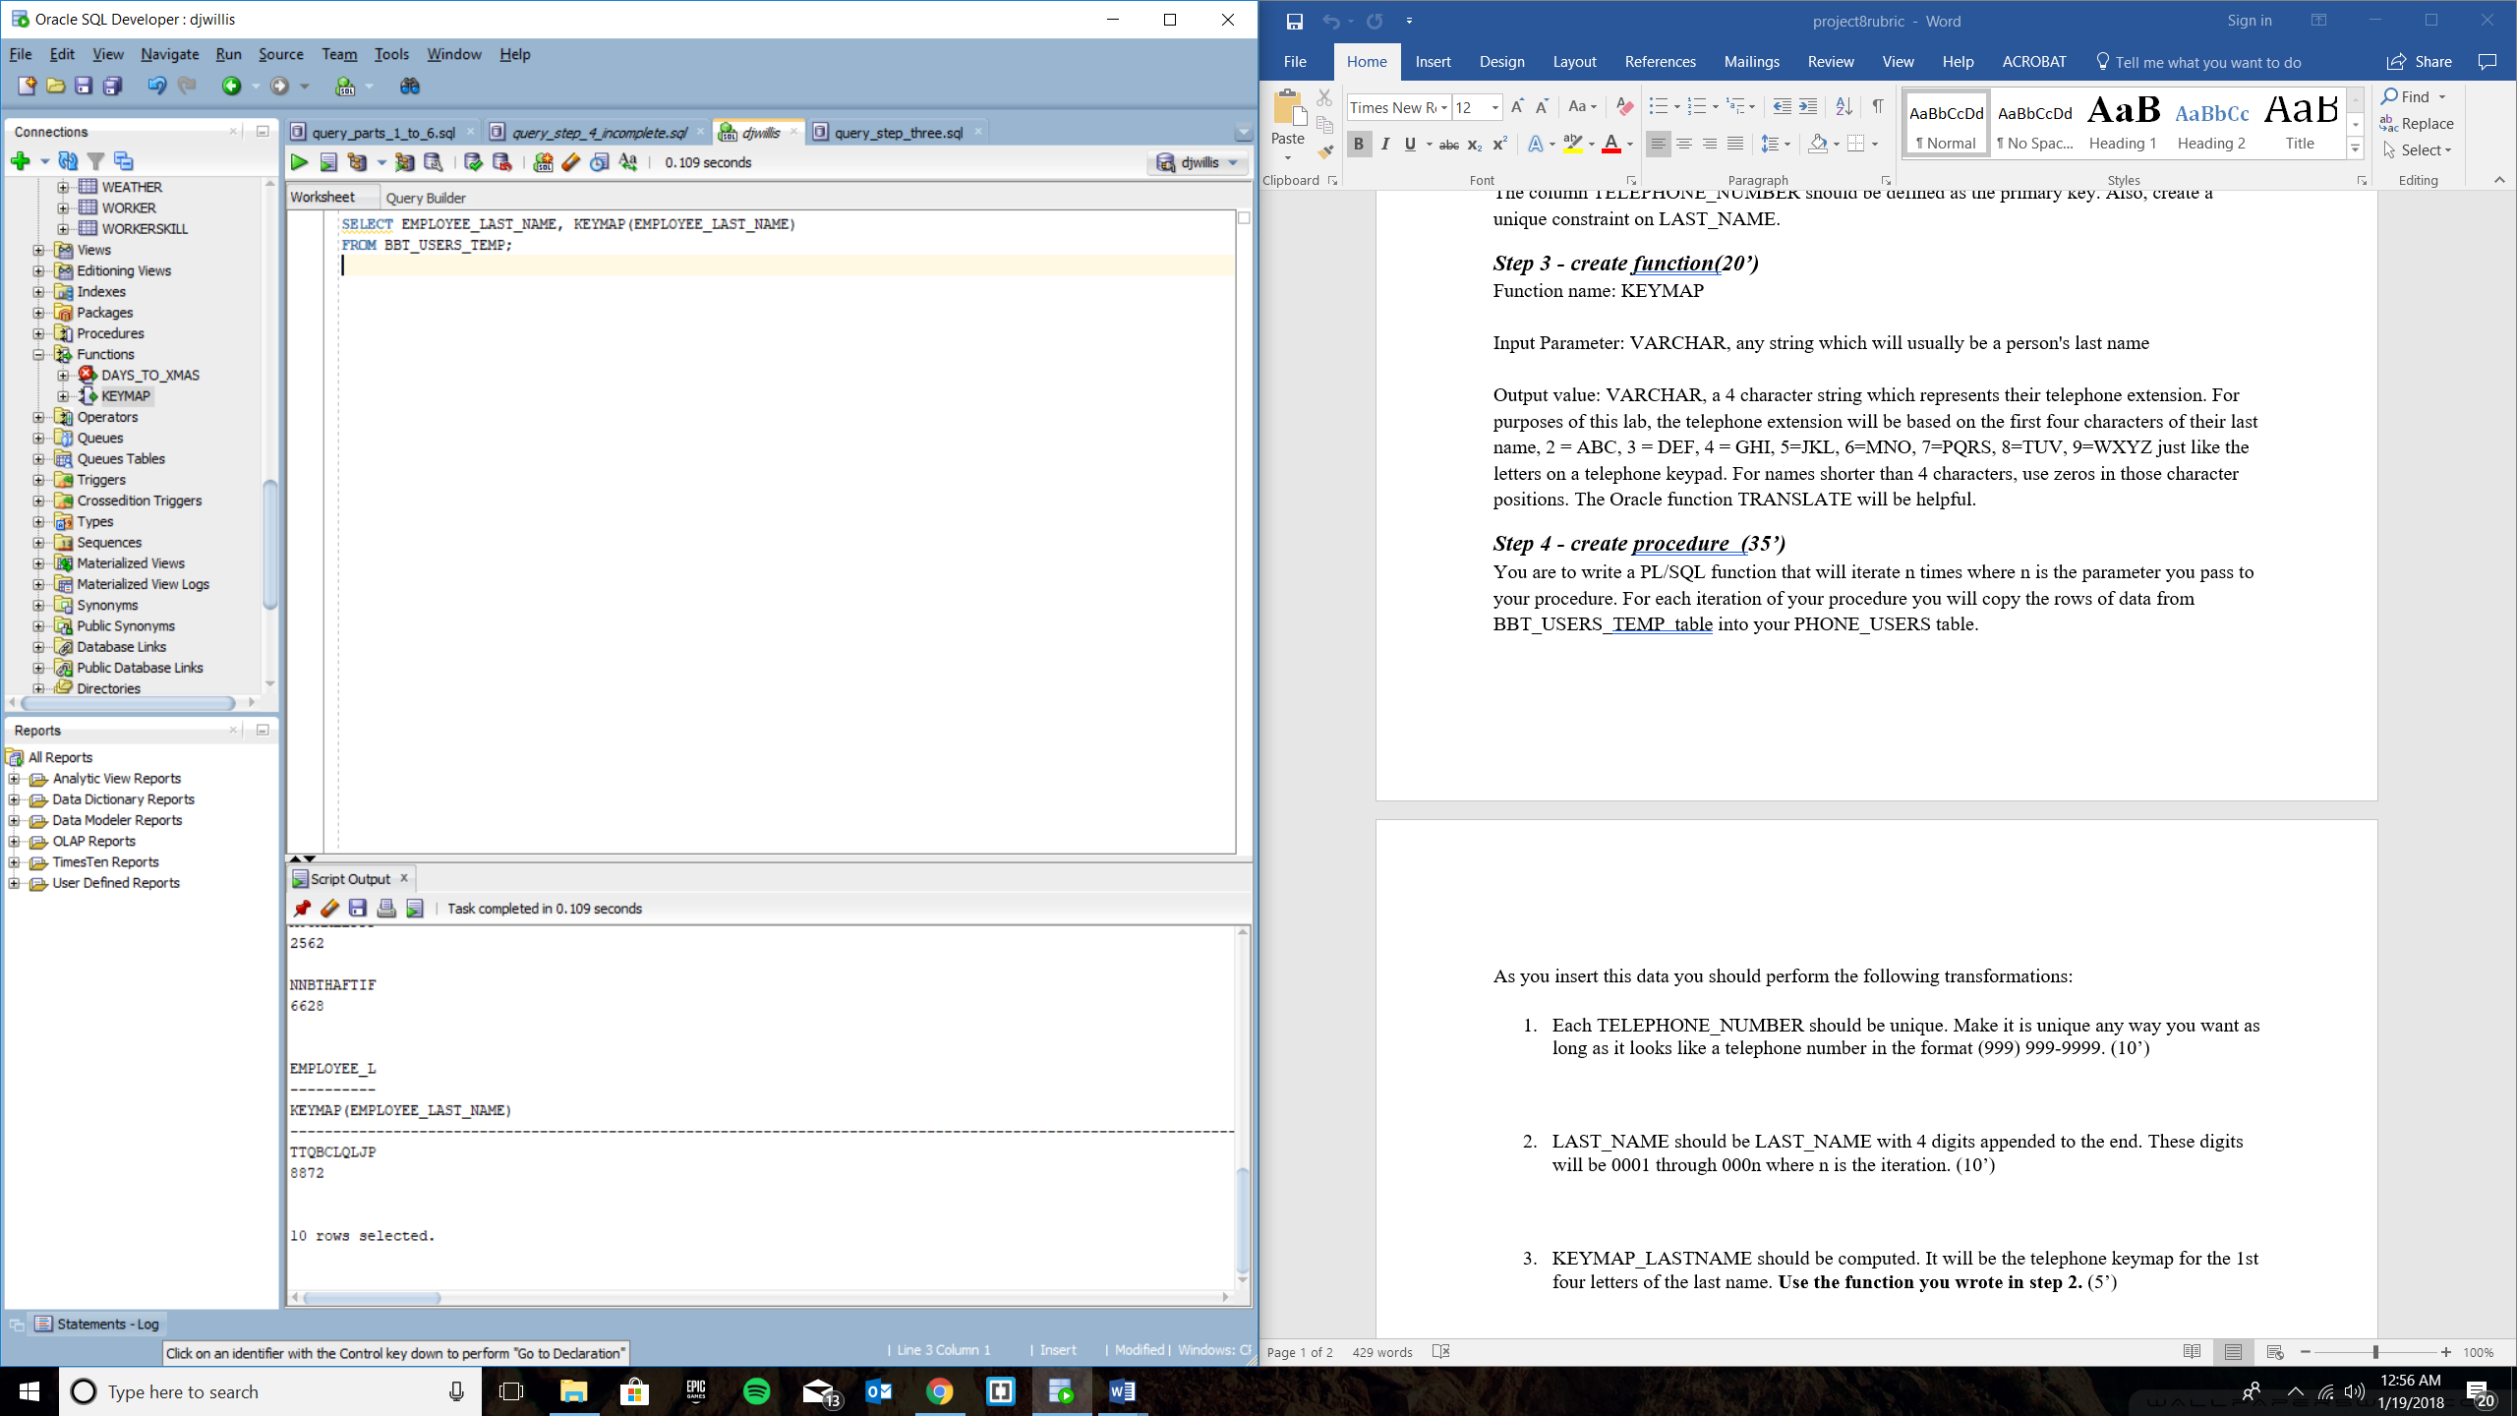

Step 4

create or replace PROCEDURE n_iterations (n in number)

AS

emp_id BBT_USERS_TEMP.EMPLOYEE_ID%TYPE;

emp_first_name BBT_USERS_TEMP.EMPLOYEE_FIRST_NAME%TYPE;

emp_last_name BBT_USERS_TEMP.EMPLOYEE_LAST_NAME%TYPE;

emp_password BBT_USERS_TEMP.EMPLOYEE_PASSWORD%TYPE;

emp_keymap VARCHAR2(40);

emp_phone VARCHAR2(40);

emp_last_name_digits VARCHAR2(40);

rand_num NUMBER;

rand_num_insert NUMBER;

x NUMBER;

CURSOR c1 IS

SELECT EMPLOYEE_ID, EMPLOYEE_FIRST_NAME, EMPLOYEE_LAST_NAME, EMPLOYEE_PASSWORD

FROM BBT_USERS_TEMP

WHERE rownum < n;

BEGIN

x := 1;

open c1;

LOOP

FETCH c1 INTO emp_id, emp_first_name, emp_last_name, emp_password;

EXIT WHEN c1%NOTFOUND;

emp_keymap := KEYMAP(emp_last_name);

SELECT ROUND(dbms_random.value(0000000000,9999999999)) INTO rand_num from dual;

rand_num_insert := rand_num;

emp_phone := '(' || substr(rand_num_insert, 0, 3) || ') ' ||

substr(rand_num_insert, 4, 3) || '-' || substr(rand_num_insert, 7, 4);

emp_last_name_digits := emp_last_name || '000' || x;

x := x + 1;

INSERT INTO PHONE_USERS VALUES

(emp_phone, emp_first_name, emp_last_name_digits, emp_keymap, emp_password);

end loop;

close c1;

end;

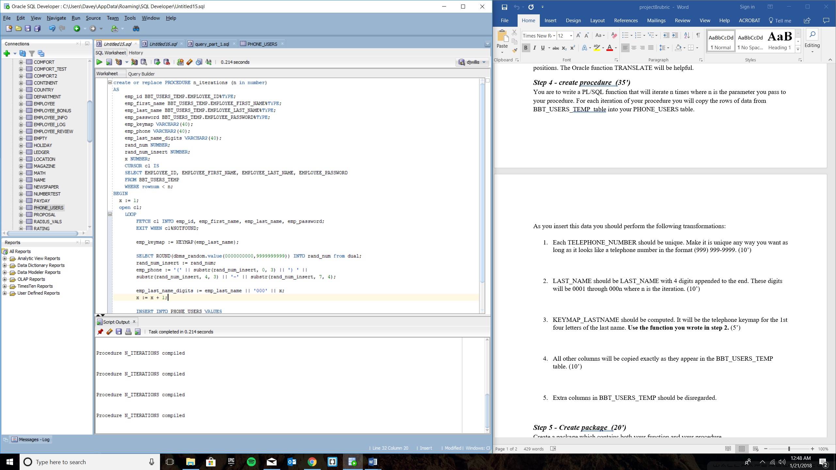

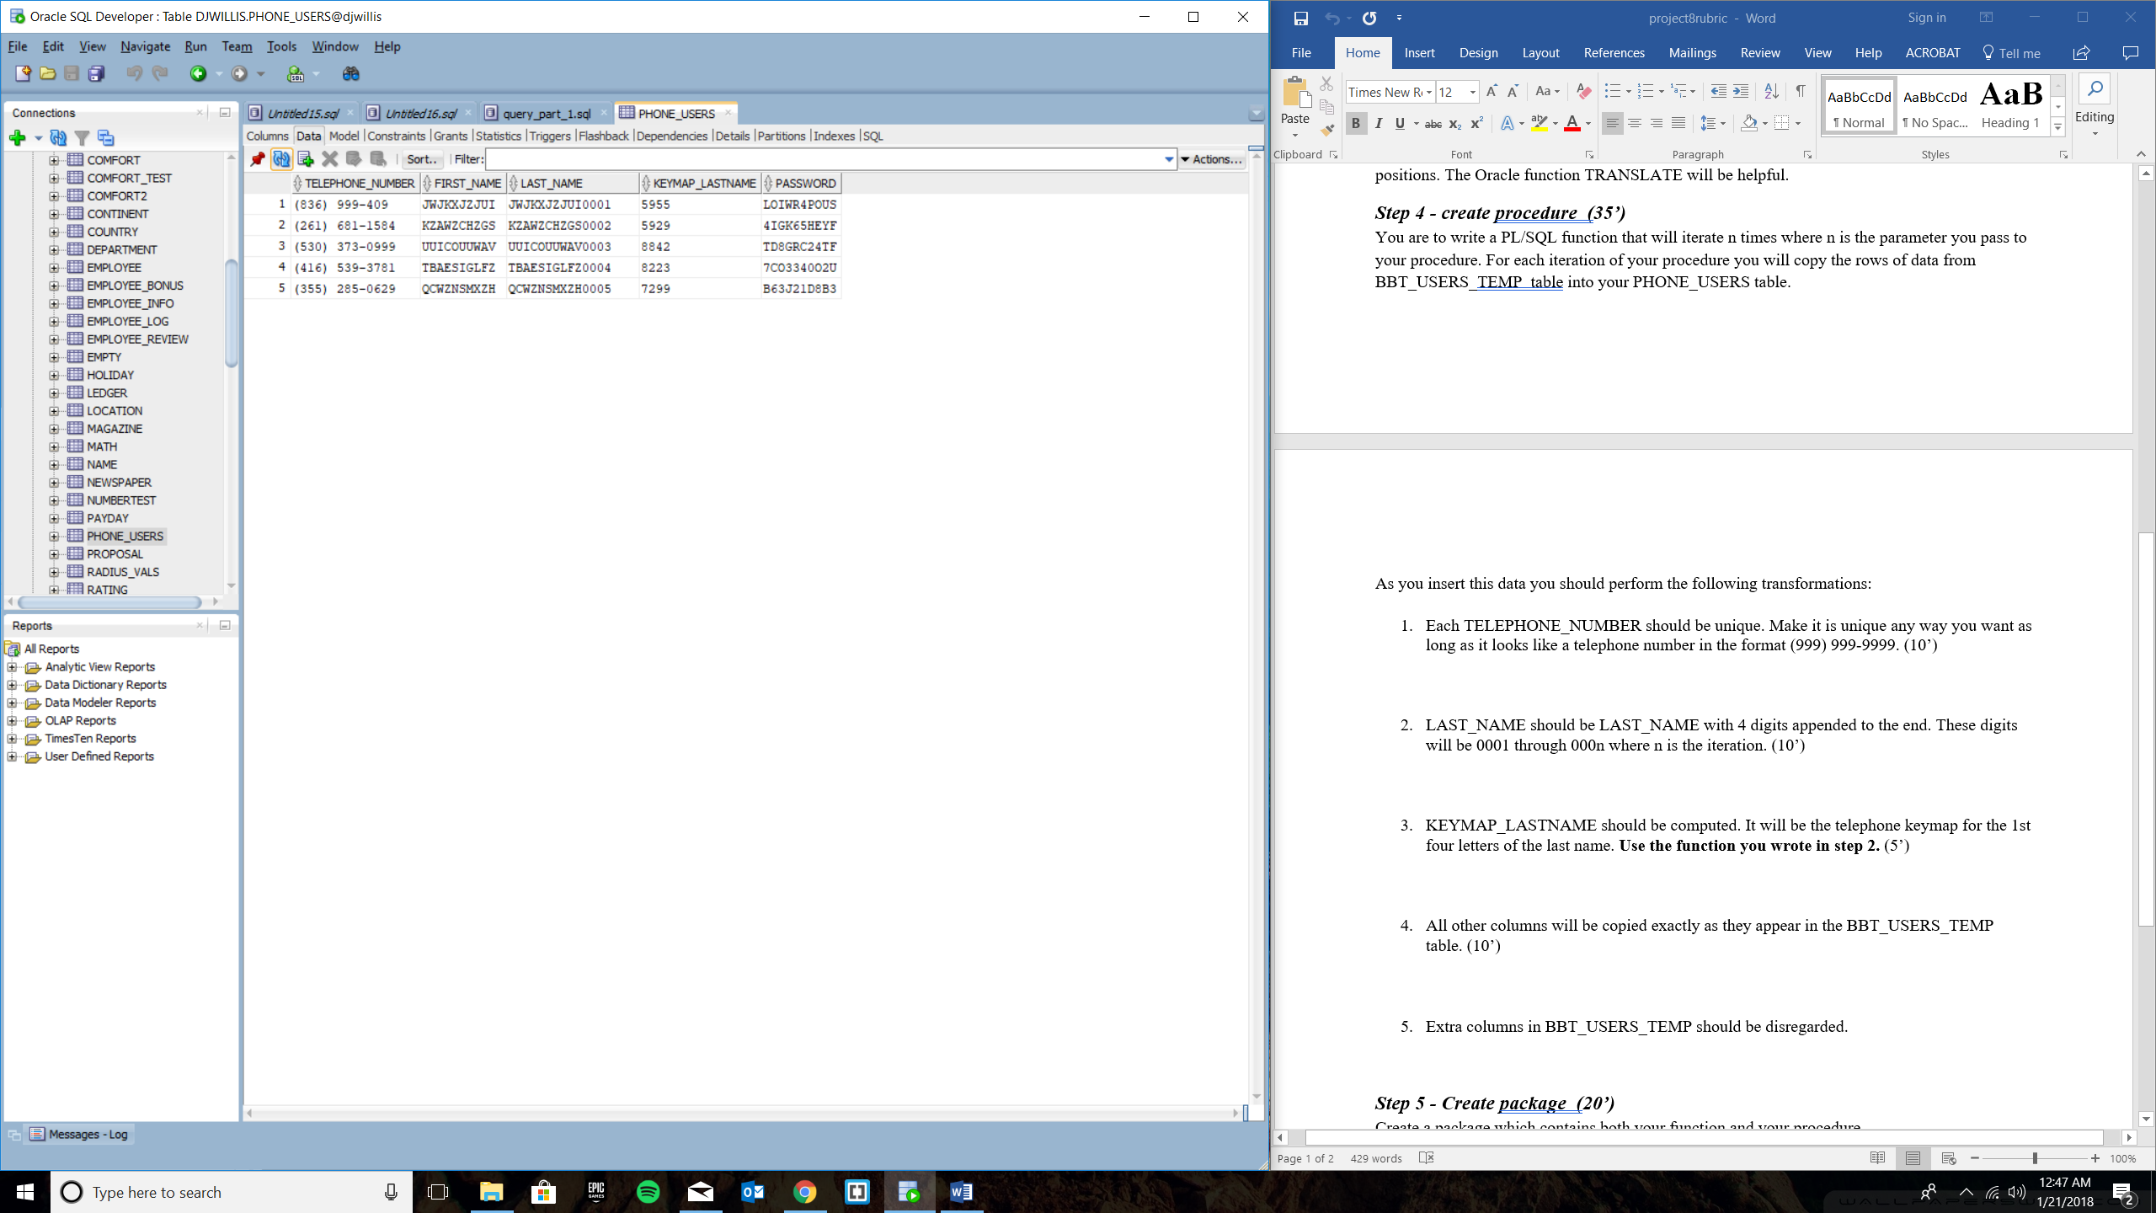

Step 5 and 6

CREATE OR REPLACE PACKAGE RUN_FUNCTIONS

AS

FUNCTION KEYMAP(A_LAST_NAME VARCHAR2) RETURN VARCHAR2;

PROCEDURE n_iterations (n in number);

END RUN_FUNCTIONS;

/

CREATE OR REPLACE PACKAGE BODY RUN_FUNCTIONS

AS

FUNCTION KEYMAP(A_LAST_NAME VARCHAR2)

RETURN VARCHAR2 AS

PHONE_EXT VARCHAR2(40);

BEGIN

SELECT SUBSTR(TRANSLATE(EMPLOYEE_LAST_NAME, 'abcdefghijklmnopqrstuvwxyzABCDEFGHIJKLMNOPQRSTUVWXYZ',

'2223334445556667777888999922233344455566677778889999'), 1, 4)

INTO PHONE_EXT

FROM BBT_USERS_TEMP

WHERE EMPLOYEE_LAST_NAME = A_LAST_NAME;

RETURN (PHONE_EXT);

END keymap;

PROCEDURE n_iterations (n in number)

AS

emp_id BBT_USERS_TEMP.EMPLOYEE_ID%TYPE;

emp_first_name BBT_USERS_TEMP.EMPLOYEE_FIRST_NAME%TYPE;

emp_last_name BBT_USERS_TEMP.EMPLOYEE_LAST_NAME%TYPE;

emp_password BBT_USERS_TEMP.EMPLOYEE_PASSWORD%TYPE;

emp_keymap VARCHAR2(40);

emp_phone VARCHAR2(40);

emp_last_name_digits VARCHAR2(40);

rand_num NUMBER;

rand_num_insert NUMBER;

x NUMBER;

CURSOR c1 IS

SELECT EMPLOYEE_ID, EMPLOYEE_FIRST_NAME, EMPLOYEE_LAST_NAME, EMPLOYEE_PASSWORD

FROM BBT_USERS_TEMP

WHERE rownum < n;

BEGIN

x := 1;

open c1;

LOOP

FETCH c1 INTO emp_id, emp_first_name, emp_last_name, emp_password;

EXIT WHEN c1%NOTFOUND;

emp_keymap := KEYMAP(emp_last_name);

SELECT ROUND(dbms_random.value(0000000000,9999999999)) INTO rand_num from dual;

rand_num_insert := rand_num;

emp_phone := '(' || substr(rand_num_insert, 0, 3) || ') ' ||

substr(rand_num_insert, 4, 3) || '-' || substr(rand_num_insert, 7, 4);

emp_last_name_digits := emp_last_name || '000' || x;

x := x + 1;

INSERT INTO PHONE_USERS VALUES

(emp_phone, emp_first_name, emp_last_name_digits, emp_keymap, emp_password);

end loop;

close c1;

end n_iterations;

END RUN_FUNCTIONS;

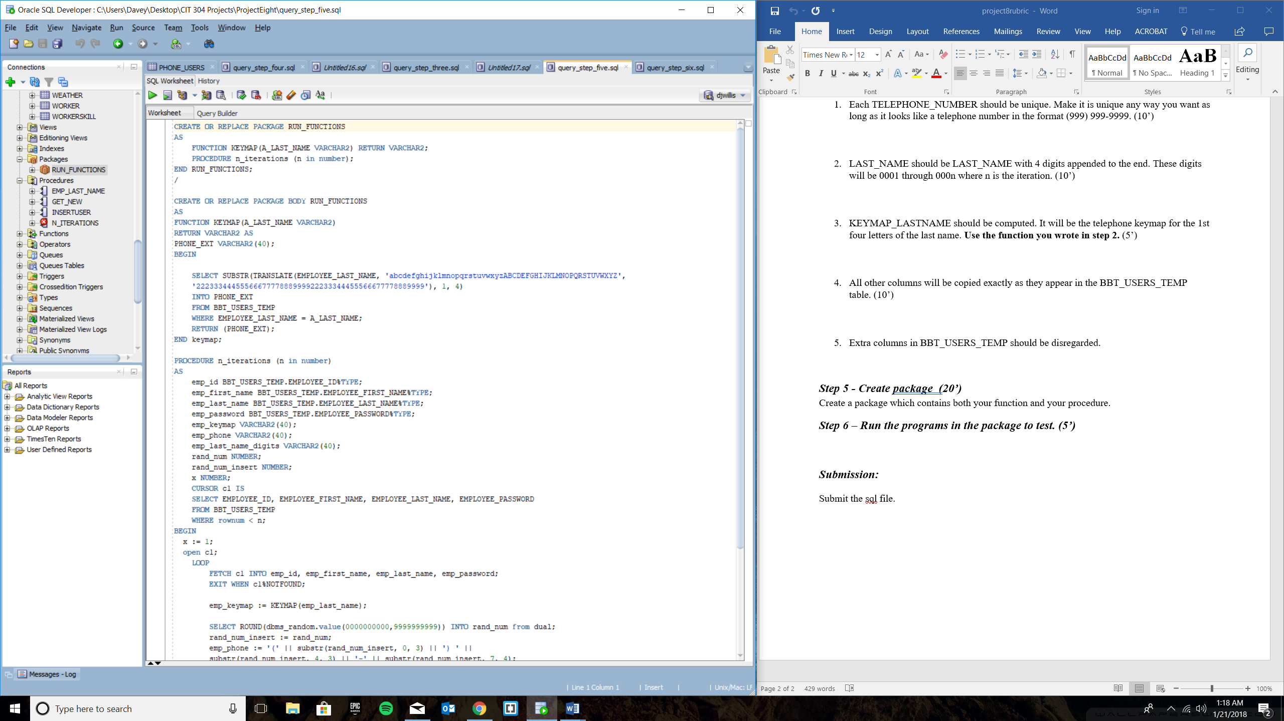

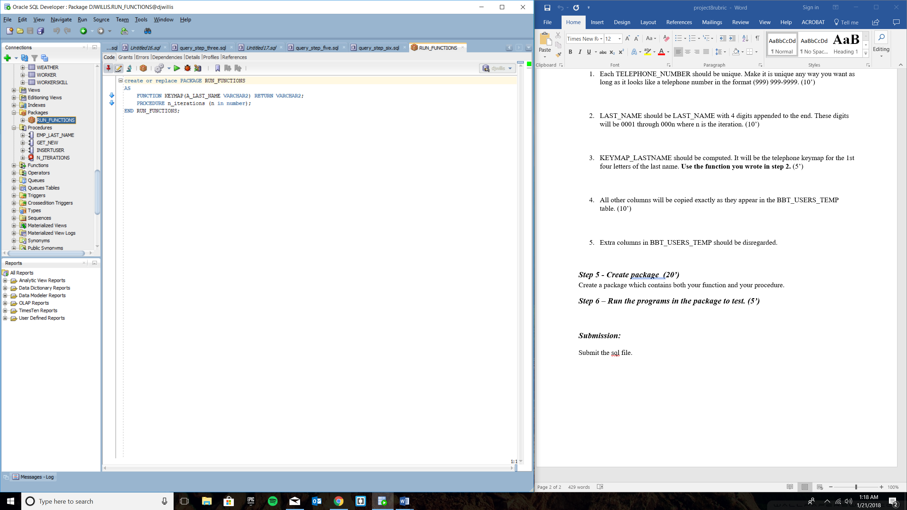

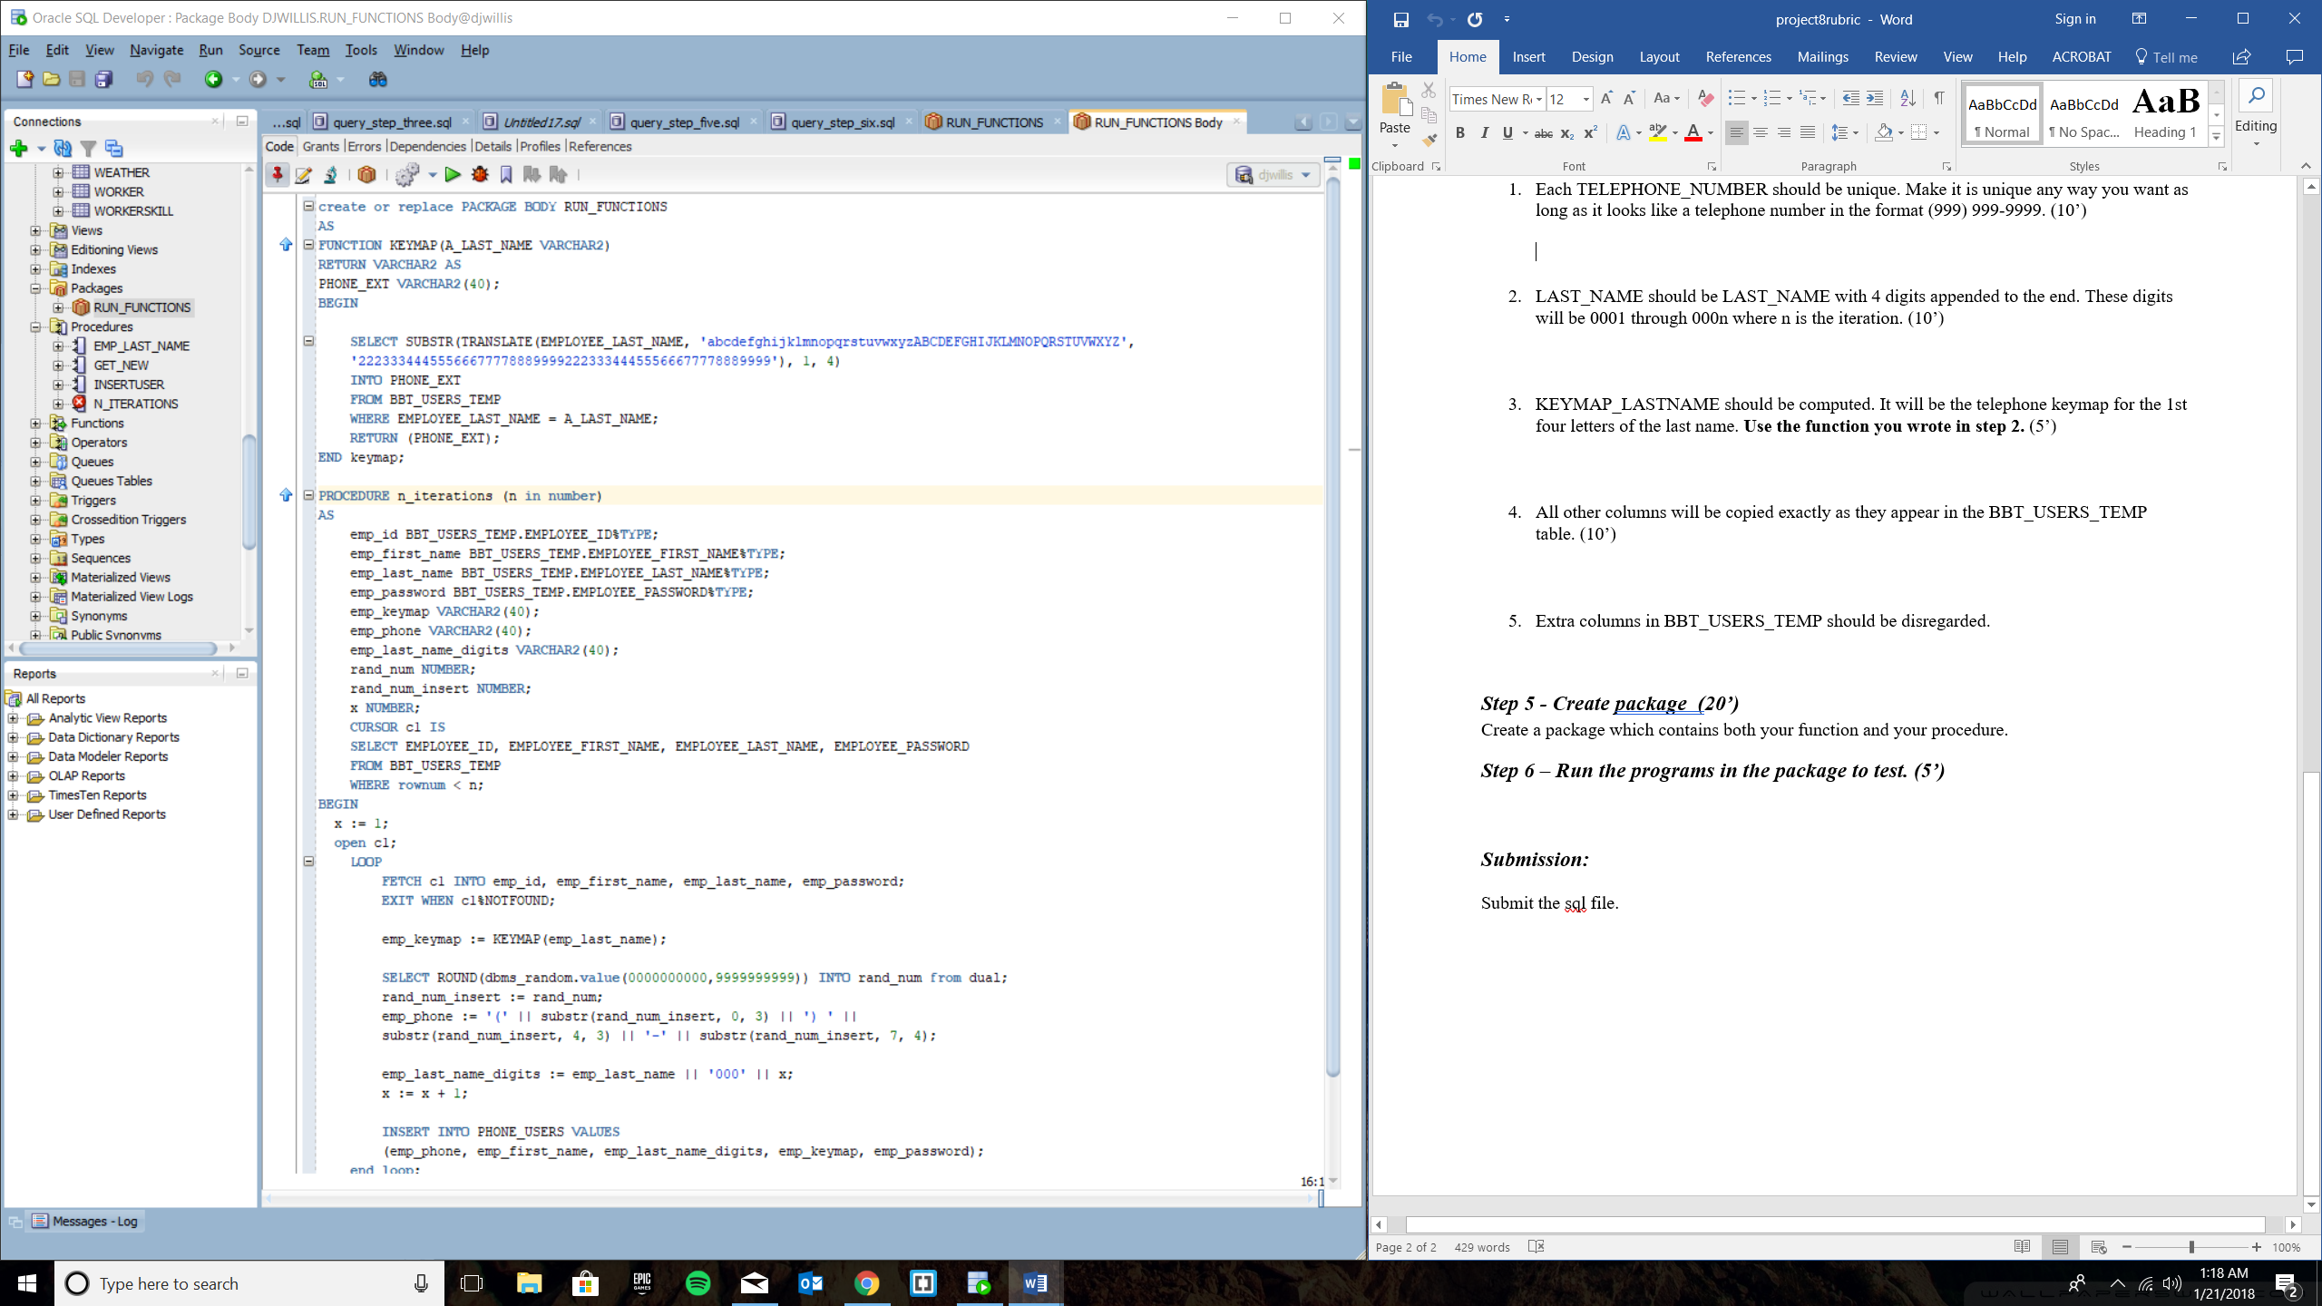

Used call statement to test if the package worked:

call RUN_FUNCTIONS.n_iterations(6);

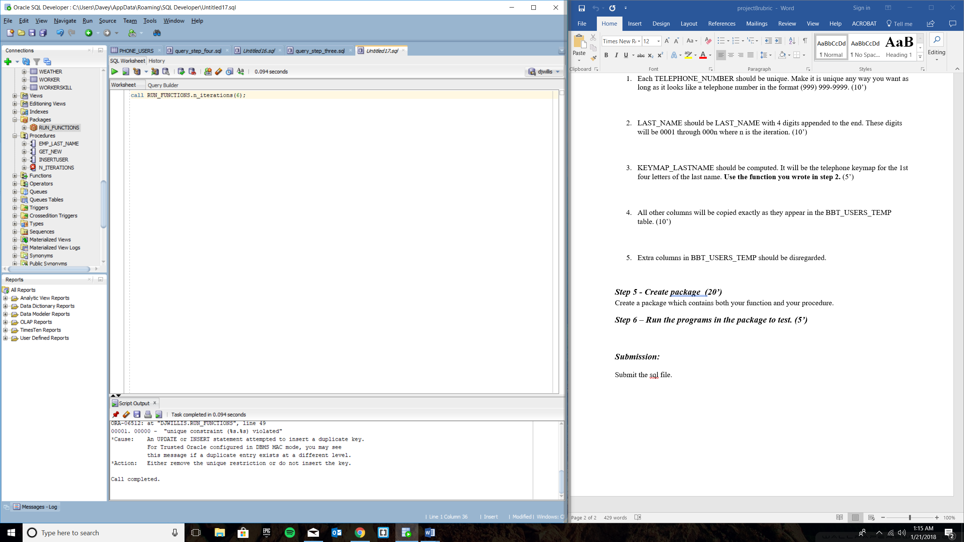

Results:

